Project Performance Appraisal

325 Fairday Drive
New York, NY

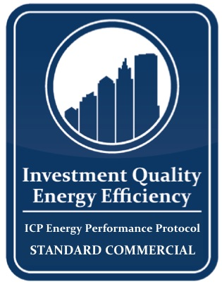
ENERGY PERFORMANCE PROTOCOL

STANDARD COMMERCIAL v.1

Project Summary 3
Building Description 3
Proposed Project 5
Project Economics 6
Energy Consumption 7
Project Team 8
Energy Modeling Method 10
Risk Factors 10
Risk Management Stragies 10
Energy Performance Protocol 12
Primary Contact 13

Project Summary
325 Fairday Drive is a 345,000 square foot office building at the corner of Fairday and 32nd Streets in Manhattan. Babson owned the property prior to its acquisition by Major Office Company Inc (MOCI) in 2002. The building is 93% occupied at market rents for the neighborhood.
Built in 1962, most of the core energy systems at 325 Fairday Drive are original. It features a primary air distribution system serving the building’s core and a secondary hot and chilled water system for perimeter induction units. The pumps and motors that move air and water throughout the building are largely 1958-vintage and constant volume. Heat comes from the Con Ed steam system, an extraordinarily expensive source of energy. A relatively new Carrier chiller cools the building, but the second chiller, a 30 year-old York, is no longer functional as a back-up. The perimeter induction units are all original pneumatically controlled and feature a unique design that inhibits air flow. There is no building management system, and in most cases the original pneumatics are no longer functional, making building management largely a manual task.
The energy savings opportunity at 325 Fairday is relatively straightforward; replacing aging technology in a shift from manual to automated controls and constant to variable volume air and water -- these are proven, reliable strategies for buildings such as this one. While co-generation and a heating plant conversion were explored, Major Office did not feel ready to consider those projects at this time. The retrofit project consists of a comprehensive building automation of the primary HVAC systems for the property, as well as converting the existing pumps and air handling units to high efficiency, variable speed systems.
Stevenson Equity Development Corp, the investor and developer in the energy systems project proposed here, has implemented comparable projects in roughly 40 buildings covering some more than 5 MM sf. These projects averaged debt service coverage (based on a 25% equity / 75% debt allocation) of 1.4 in the first year and rising each year thereafter.

Building Description
- Building Asset Information:
  - Sq. Footage: 340,000 Sq. Ft.
  - Address: 325 Fairday Drive, New York, NY
  - Use Types: Office Building
  - Occupancy: 20 percent vacancy
  - Hours of Operation: Operations of major building systems follow a 7 AM – 6 PM schedule on weekends with minimal operations weekends and holidays.

  - Age: 1962

  - Photo / Map:
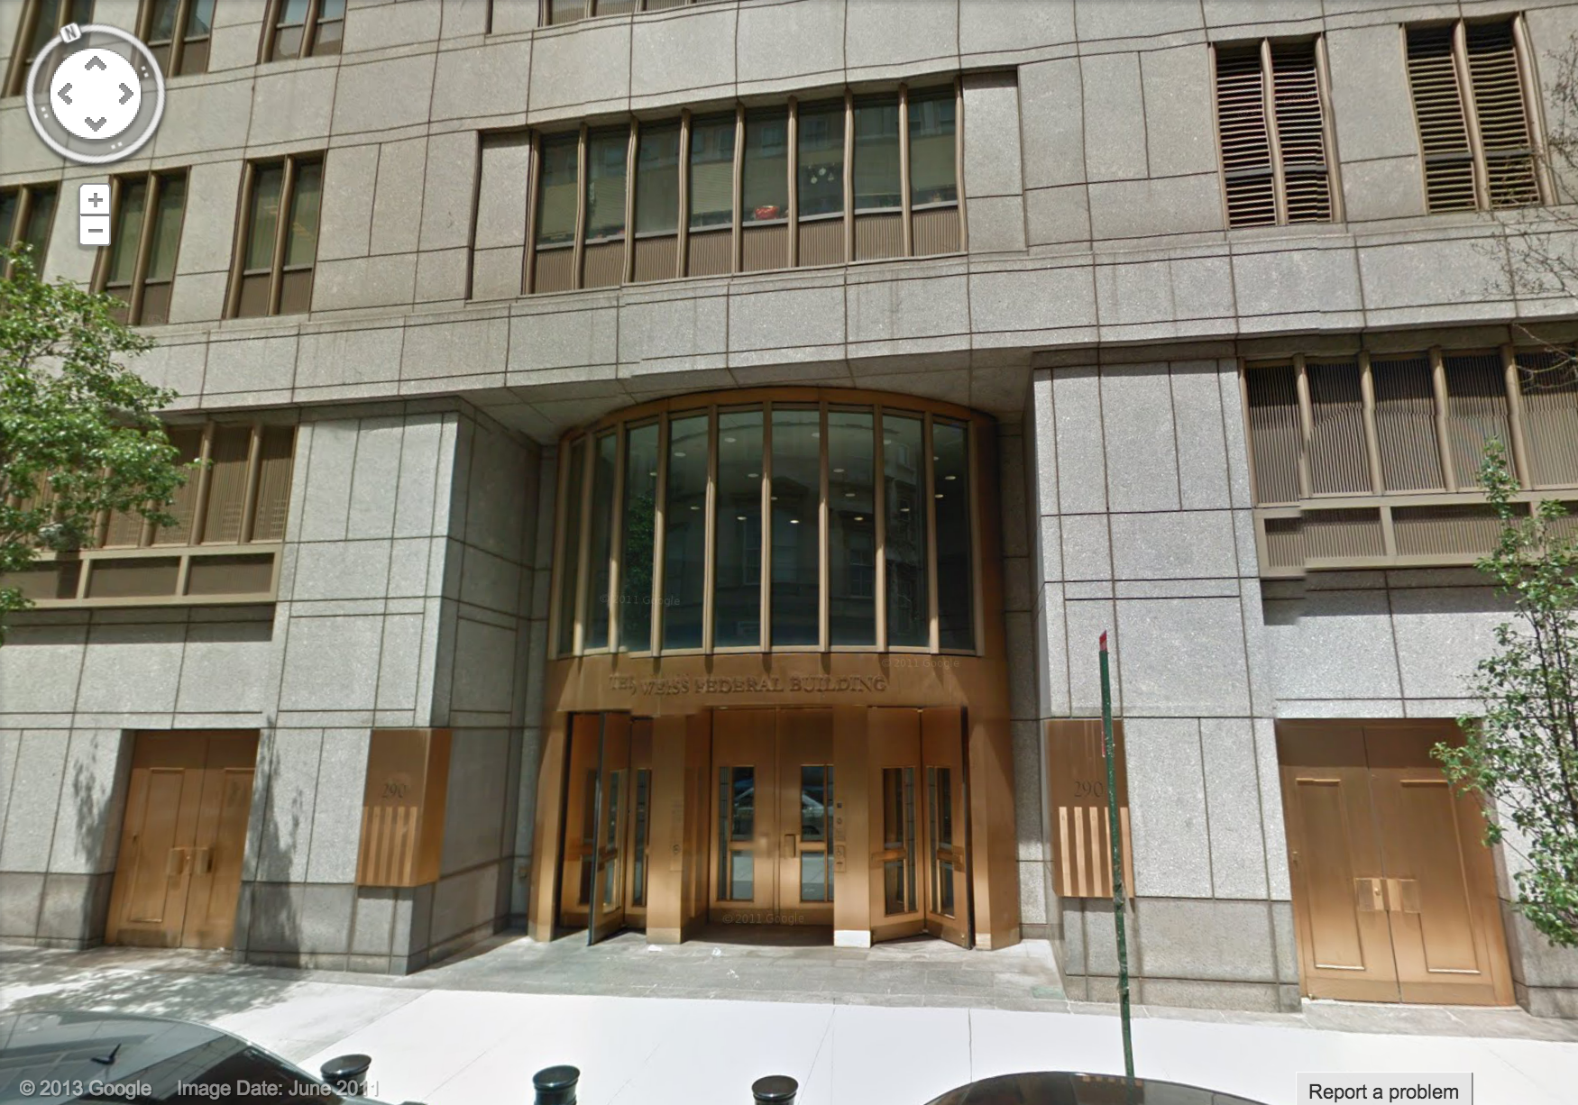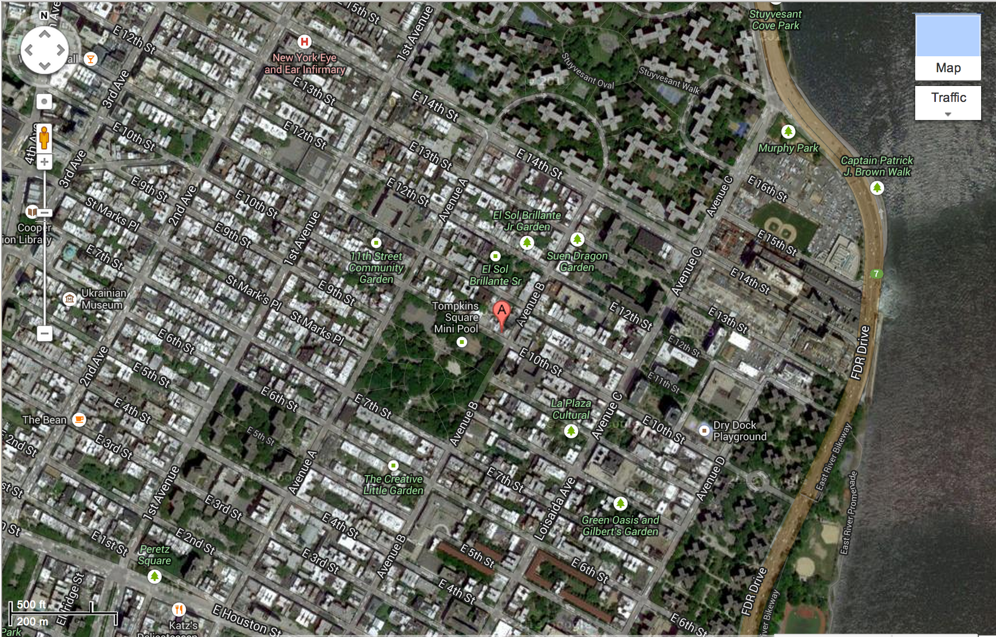
- Ownership: Major Office Company Inc
- Current Conditions:
There is a central HVAC system serving the entire building, with a primary air distribution system serving the core and secondary hot and chilled water distributed to perimeter induction units. Heat for the building comes from high pressure Con Ed steam stepped down to much lower pressure and used to preheat coils on primary air handling units and to heat water via a heat exchanger for the perimeter induction unit system. There are building setbacks at floors 12 (there is no 13th floor) and a second setback at floor 16.

There are two mechanical floors at the top of the building and a below-grade cellar beneath. A relatively new 450-ton Carrier centrifugal chiller carries the bulk of the central cooling load because the 20-year old 350-ton York chiller held as a back-up is not functional. On most floors the core duct work has been modified to accommodate supplemental cooling units. The induction units are all original pneumatically controlled and, as described later, feature a unique design that inhibits air flow. Floors 10-12 have been retrofitted with new Carrier perimeter induction units. Steam pre-heat coils are used extensively to make up for the relative inefficiency of the older induction units.

Domestic hot water is also steam-driven – via a heat exchanger in the summer and condensate in the winter.

Ventilation systems are constant volume. Outside air dampers are manually controlled. Most motors powering supply and return fans are original. A project is currently underway to install floor isolation dampers.

There is no building management system, and in most cases the original pneumatics are no longer functional.

Lighting is a mix of T-12s with magnetic ballasts and newer T-8 fluorescents

Proposed Project
- Project Description:
The retrofit project proposed consists of a comprehensive building automation of the primary HVAC systems for the property, as well as converting the existing pumps and air handling units to variable speed systems. Lighting retrofit and controls.
- EPA Portfolio Manager Pre / Post:
Pre-retrofit
Energy Usage Index: 89 kBTU/sf
Energystar Score: 71

Projected Post-retrofit
Energy Usage Index: 64 kBTU/sf
Energystar Score: 88

- ECM Descriptions
Measure Description | Status | Fuel Type Saved | Energy Saved in kWh | Energy Saved in kW | Energy Saved in mmBTUs | Annual Dollars Saved | Bids | Simple Payback Period (yrs)
Energy Management System and AEM | R | Elec, MMBTU | 243,281 | -3 | 3,745 | $147,238 | $434,871 | 2.95
Floor Isolation Dampers | R | Elec, MMBTU | 460,133 | 57 | 420 | $58,087 | $417,580 | 7.2
Variable Frequency Drives | R | Elec | 225,113 | -11 | 480 | $63,640 | $232,900 | 3.66
High Efficiency Motors | R | Elec | 19,388 | 0 | 48 | $3,600 | $58,398 | 16.5

Project Economics
- Total Project Cost: $1,487,690
- Total Estimated Savings: $241,690
- Bid / Estimating Process:
Stevenson Equity hosted walk-through of 325 Fairday Drive with six mechanical contractors and four controls firms. Three mechanical contractors and all four controls firms submitted actionable bids. Stevenson then reviewed pricing and project approach with each of them, requesting adjustments to ensure adequate leveling and fair comparison. The selected contractors were deemed the best combination of price and quality. Actual bids and bid documents are available upon request.
- Benchmarks and Comps:

Energy Consumption
- Energy Cost, Usage, Rate by Meter:
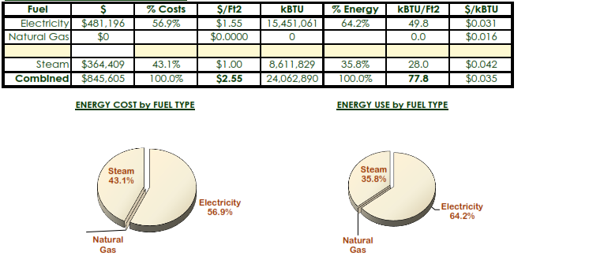
- Pre and Projected Savings:
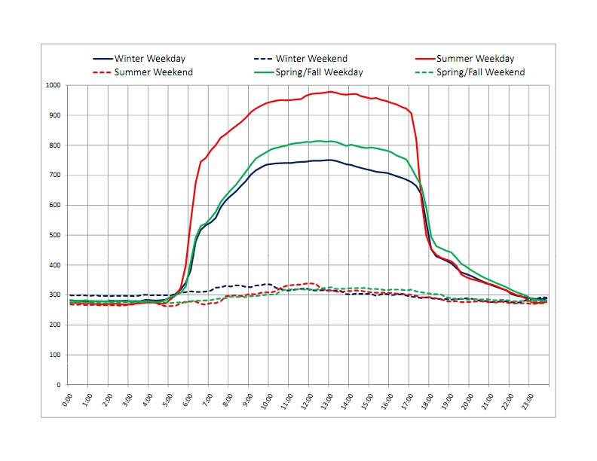
- Description of Energy Purchasing and Tariffs:
325 Fairday Drive purchases electricity from Discount Bulk Energy Services and delivered through ConEdison of New York. ConEdison charges are regulated by the New York State Public Service Commission while Discount Bulk Energy Services charges are deregulated and negotiated in the open market. Energy charges through Discount Bulk Energy are currently $0.0987/kWh plus 2.444% gross receipts tax. Charges from ConEdison are composed of demand delivery charges ($34.83 per kW summer and $14.44 per kW winter); energy delivery charges of $0.0071 per kWh; billing and metering charges of $64.94 per month; various fees, surcharge and adjustments running about $.026 per kWh; and taxes of 2.3867% for gross receipts and 4.5% for state and local sales taxes. The cost of electric energy during the study period averaged about $31 per mmBTU.
Steam is purchased from ConEdison Steam Operations via its district steam system. Steam charges are also regulated through the NYSPSC and are billed on a declining block structure (cost per unit varies with the amount of consumption) that changes between summer and winter periods. Summer charges vary between $14.555 and $18.892 per thousand pounds. Winter charges vary between $16.371 and $39.155 per thousand pounds. There are additional fuel adjustment and surcharge that ran about $5.20 during the study period. Monthly metering and connection charges are $3442.29. Taxes consist of 2.444% gross receipts tax, 4.5% local sales tax and 4.375% state sales tax.
Detailed electric and steam tariff structures are available upon request.

Project Team
- Project Developer:
Steve Jonson
Director
Stevenson Equity Development Inc
225 15th Street, Suite 615
Brooklyn, NY 11238

- Professional Engineer:
Frank Illner
Illner Associates Consulting Engineers
233 Avenue of the Americas
New York, NY 10018
(license information available)

- Construction Firms:
Mechanical
Joseph Delmarco
Ultra Comfort
31 Berden Avenue
Long Island City, NY 11101

Controls
Steve Ratford
Automated Building Systems
1005 Montana Ave, Suite 400
Clifton, NJ 07014

Construction Management
Constantine Kaldernet
Superior Energy Solutions
125 George Place
Delmar NY 12054

- Asset Owner:
Rick Montray
Director of Asset Management
Major Office Company Inc (owner and managing agent, 325 Fairday Drive)
555 Seventh Avenue
New York, NY 10003

- Property Manager:
John Loden
Building Manager
Major Office Company Inc
325 Fairday Drive
New York NY 10038

- Major Tenants:
Gifford Private Equity Fund
Deluxe Fashion Label
Telecom Inc
Shoemaker & Thomas Attorneys at Law

Energy Modeling Method
- Model Description:
ECM savings were determined using eQUEST version 3.63b, a Microsoft Windows based graphical interface for the DOE 2.2 calculation engine. DOE 2.2 is an 8,760 hour public domain building simulation program sponsored by the U.S. Department of Energy.
An eQUEST model of the existing building conditions was created and calibrated to within +/- 5% of actual base period annual usage for all fuel types and categories.
ECMs were simulated with this model using the eQUEST Parametric Run feature. Each ECM parametric run was based on the previous iteration; i.e., the ECM 1 run was based on the Base model run, the EEM 2 run was based on ECM 1 run, etc. This approach ensures that interaction is accounted for among the ECM’s. Input parameters for the models are available upon request.
ECMs were selected for testing based on the preferences of the managing agent and ownership as well as recommendations of multiple engineers with decades of experience reviewing the building and its operations over a period of months.

Risk Factors
- Minor cost risk associated with asbestos and the condition of valves in ceilings that will not be exposed until project commences. Mitigated as much as possible through construction contract and contingencies.
- Management coordination risk associated with additional project implemented by landlord – installation of a chiller.
- Operator risk from unreported additions to building or operational changes that increase energy usage.

Risk Management Stragies
- Construction:
Mitigated as much as possible through construction contract and contingencies. Consolidating project management for the two projects and utilizing the same contractors for electrical and controls elements will help ensure adequate communication and coordination.

- Design, Construction, Commissioning:
All improvements to be fully commissioned and controls sequences to be tested and refined over a period of months. See “Ongoing Assurance” below for further post-construction monitoring activity.
- Ongoing Commissioning / O&M:
Stevenson Equity will bill based on kWh and MMBTUs in the baseline, with rate floating based on landlord procurement.

Project is underwritten to a floor rate Fairday Drive has agreed to pay regardless of rate movements.
The performance assurance software will monitor all control points in the building, harvest and trend data and identify actions required to ensure savings persist. The trending capacity will also identify departures from projected usage in real time, identifying operational changes or additions to building systems.

The software performs two critical. First, it reports problems and opportunities to the building operator that otherwise might have been missed, protecting the savings created by the project.
Second, it reports the problems to the finance firm. In instances where operations depart from those required under the contract (e.g. air handlers are on when they should not be) building operators will be notified and, if remedial action is not taken, make adjustments to the bill to account for any increased energy usage.

Energy Performance Protocol
- Energy Performance Protocol – Standard Commercial v1.0

  - Verification Date:
7/29/2013

  - Third Party Quality Assurance Provider:
Greg Matson, PE
Solid Engineering
355 Parkway Blvd.
New York, NY

- Energy Performance Protocol PE Certification
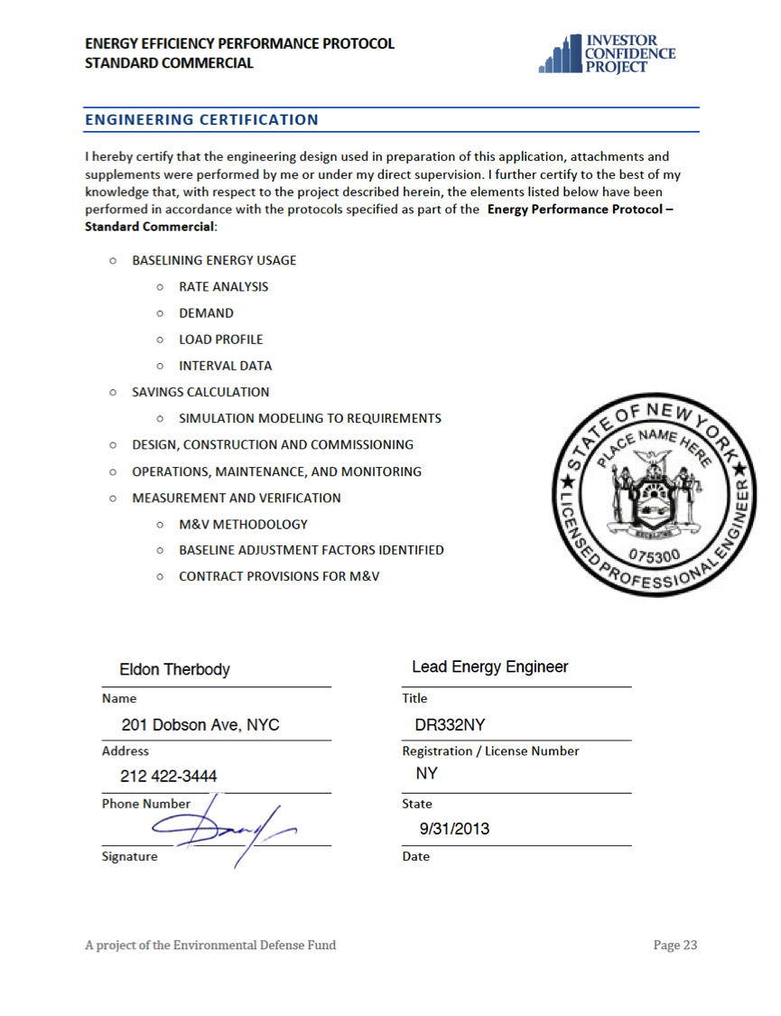

Primary Contact

Steve Jonson
Director
Stevenson Equity Development

Steve.Johnson@sed.com
225 18th Street, Suite 734
Brooklyn, NY 11238

